Performance Oriented Accurately Controlled High-speed Egg-sorting Device (POACHED)

EGG-Sortinaire (EGGS)

Concept of Operations

Sunday, January 11th

Prepared for
Federated Ring of Integrated Egg Distributors
(FRIED)



Table of Contents

Paragraph Page
Table of Contents 2
List of Illustrations 3
List of Tables 3
1.0 SCOPE 4
1.1 Identification 4
1.2 Product Overview 4
1.3 Document Overview 4
2.0 APPLICABLE DOCUMENTS 4
2.1 Project specification 4
2.2 TDB Project Standards 4
3.0 CURRENT PRODUCT OR PRODUCT SITUATION 4
3.1 Current Mission and Scope 5
3.2 Current Product Description 5
3.3 Current Personnel Aspects 5
4.0 OPERATIONAL CONCEPT of the new product 5
4.1 Assumptions 5
4.2 New Mission and Scope 5
4.3 Product Functions 6
4.3.1 States and Modes 6
4.3.2 Operation in Specific States or Modes 6
4.4 Operational Environment 6
4.5 Support Concept 6
4.6 Personnel and Training 7
4.7 Summary of Organizational Impacts 7
4.8 Product Evolution 7
5.0 Performance Characteristics 7
5.1 Key Operational Requirements 7
5.1.1 Mission Critical Capabilities 7
5.1.2 Key Performance Requirements 7
5.1.3 Quality Factors 7
5.2 Measures of Effectiveness (MOEs) 8

List of Illustrations
Figure Page

<TBD>

List of Tables
Table Pag

<TBD>

Performance Oriented Accurately Controlled High-speed Egg-sorting Device (POACHED)«ProjectName»

Egg-Sortinaire (EGGS)

Concept of Operations

SCOPE

Identification

This document describes the Concept of Operations (CONOPS) for the Egg-Sortinaire (EGGS) system; Version 0.1.

Product Overview
The purpose of the product is to provide the user with a portable, efficient system for sorting eggs by size. The product will optimize sorting time, while minimizing egg breakages and checks. In the past, local farmers have manually inspected, sorted, and packaged eggs in the field at each farm stop. This product intends to revolutionize the industry by simplifying this tedious process. It is fast, easy-to-use, and precise. Its portable framework allows it to be easily transported to service each farm site.

Document Overview
The purpose of this Concept of Operations is to collectively organize system information, to define project assumptions, and to explain preliminary system design concepts and operating goals. This document should not be distributed to any competitors.

APPLICABLE DOCUMENTS
Paragraphs 2.1 through 2.2 list the references that form this document to the extent specified herein. In the event of conflict between the documents referenced herein and the contents of this document, the contents of this specification shall govern.

Project specification
The project specification document is “Portable Egg Sorter Project Rev E6.doc.” The date of this publication is May 5th 2009. This document gives a project overview along with customer requirements.

TDB Project Standards
The Project Standards come from the United States Department of Agriculture. The publication referenced herein is the “United States Standards, Grades, and Weight Classes for Shell Eggs.” The effective date of the document is April 6th 1995.

CURRENT PRODUCT OR PRODUCT SITUATION
The Federated Ring of Integrated Egg Distributors (FRIED) would like a system to be designed by ELDP Solutions that modernizes current egg-sorting systems. Our new product, EGG-Sortinaire (EGGS), looks to modernize the egg-sorting process through the use of automation techniques, speed-driven yet safe egg handling, and a design that allows for fast setup and breakdown times.

Current Mission and Scope
FRIED uses a manual, mobile system to collect and sort eggs from farmers. The current manual egg-sorting process is impractical for the volume of eggs that the farmers produce. Too much time is being spent on manually sorting eggs based on class/size with the current implementation. The EGGS system removes the high overhead caused by manually sorting eggs.

Current Product Description
The FRIED organization travels in their mobile processing and packing van to different member farms. Once on site, they inspect, sort, and box the eggs for immediate distribution. The current system for egg-sorting is fully manual in nature.

Current Personnel Aspects
The majority of the current users are local farmers running small family-owned businesses. The inefficient sorting techniques require FRIED members to perform sorting and packaging tasks on an overwhelmingly increasing volume of eggs. New farmers must be trained in the technique, which can cause setbacks in time and finances. The current sorting method is highly subjective amongst varying egg sorters and may lead to inconsistencies in sorting patterns.

OPERATIONAL CONCEPT of the new product

Assumptions
- TBD references herein will be resolved with customer clarifications.
- The input and output interfaces are identical across all farms being serviced by FRIED.
- In the farm field environment, we assume there will be an area where our product can operate on a completely flat area.
- Our system will operate in an enclosed farm structure that is not susceptible to any environmental hazards such as adverse weather conditions.
- All users of EGG-Sortinaire (EGGS) have been properly trained to operate our system.

New Mission and Scope
The goal of EGGS is to modernize the current implementation of egg-sorting used by the Federated Ring of Integrated Egg Distributors (FRIED). EGGS looks to eliminate the manual classification effort and replace it with an automated and faster egg-sorting system. Focusing on the family farmer, efficiency, ease of mobility, and a simple operator interface are critical factors that will be incorporated into our design.

<TBD: Talk about input/output methods, automation techniques, speed control, design>

Product Functions
The EGGS autonomously sorts eggs by size. It accepts an input and meets specified output criteria. It is capable of processing eggs at a user variable rate.

States and Modes
EGG-Sortinaire can operate in a series of modes as shown in the diagram below.

Input Stage: The system is prepared and loaded with eggs up to the capacity of EGGS.
User Configuration: The user configures EGGS to operate as desired.
Normal Operation: EGGS sorts the eggs presently loaded.
Sort Complete: The system completely sorts all loaded eggs and is waiting for more input or is prepared to enter the transport stage.
Transport: If necessary, cease operation mode. Clean the system. Break down and pack the system.
Error: This state captures all failures within stages which are non-recoverable.
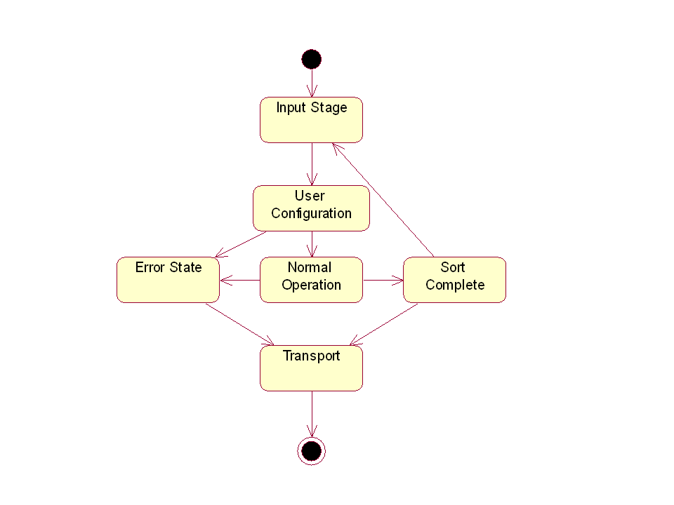

Operation in Specific States or Modes
<TBD>

Operational Environment
EGGS will operate in an indoor, farm environment on an even surface.

Support Concept
<Desired Goal> → Not in any way a requirement
(Levels of Maintenance / Maintenance & Repair Cycles)

Personnel and Training
Typical users of EGGS are members of the FRIED organization. Training will be minimal and simple, encompassing proper techniques for the setup, operation, breakdown, and transport of EGGS.

Summary of Organizational Impacts
EGGS may require the integration of additional equipment, which may result in added costs incurred by the user. It may also call for further personnel training.

Product Evolution
<TBD> → Expand to future markets?

Performance Characteristics

Key Operational Requirements

Mission Critical Capabilities
According to Contractual Requirement 1.4.3, the device shall have provision for protection measures such that if an egg drops from either the sorter or the handler, it shall not soil the floor. [071]

Key Performance Requirements
According to Contractual Requirement 1.4.1, the maximum processing rate shall be no less than 500 eph (eggs per hour). [040] The system shall also count the number of eggs processed.

According to Contractual Requirement 1.4.3, the device shall minimize breakage and checking.

Quality Factors
According to Contractual Requirement 1.4.2, the device shall work in a farm field environment. [060].

According to Contractual Requirement 2.2, the site breakdown and packing time shall be no longer than 8 minutes. [120]

According to Contractual Requirement 2.2, normal post operation cleaning (if any is required) shall be included when calculating breakdown and packing time. [130]

According to Contractual Requirement 2.1, the device must be easily portable by one person. [090].

According to Contractual Requirement 2.1, on site setup time shall be no longer than 5 minutes. [100]

Measures of Effectiveness (MOEs)
Measures of effectiveness that will be used to gauge system success are as follows:
- Number eggs sorted per hour (eph)
- Minimization of breakage and checking (establish a metric)
- Egg sorting accuracy
- Setup, breakdown and cleanup time

